**Circuit Diagram** Team ID: PNT2022TMID49784

Transmitter

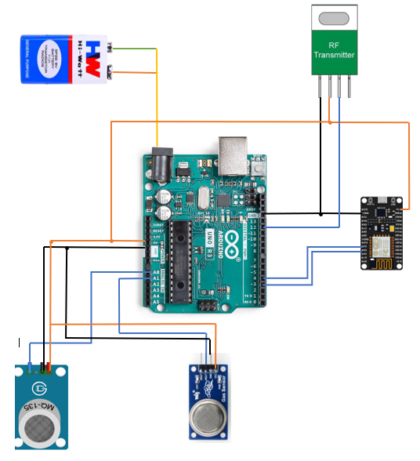

Receiver

